**FPT ACADEMY INTERNATIONAL**



**FPT – APTECH COMPUTER EDUCATION**

**Crystal Products**

|  |  |  |  |
| --- | --- | --- | --- |
| **Center Name** | | FPT – Aptech – HCM2  Address: 590 Cach Mang Thang Tam, District 3, Ho Chi Minh City | |
| **Instructor** |  | Ms. Le Mong Thuy |  |
| **Class** |  | T1 2303.MO |  |
| **Group** |  | 6 |  |
| **Group members** | | **Name** | **Student ID** |
|  |  | Nguyen Lam Nguyen Vu | Student1462837 |
|  |  | Nguyen Minh Thien | Student1459126 |
|  |  | Vo Nhat Hoang | Student1459127 |
| **Duration** | Start date | 19th June 2023 |  |
| End date | 26th July 2023 |  |

**This is to certify that**

**Mr.:**

Nguyen Lam Nguyen Vu

Nguyen Minh Thien

Vo Nhat Hoang

**has successfully designed & developed**

eProject: Crystal Products

**Submitted by:**

Nguyen Lam Nguyen Vu

**Date of issue:**

**Authorized Signature:**

**TABLE OF CONTENTS**

ACKNOWLEGMENT 3

SYNOSIS 3

PROBLEM DEFINITION 5

CUSTOMER'S REQUIREMENTS SPECIFICATIONS (CRS) 6

SCOPE OF THE WORK (IN BRIEF) 8

DIAGRAM OF THE WEBSITE 9

TASK SHEET REVIEW 1 10

SITE MAP 11

MOCK OF THE WEB SITE 12

1. Homepage 12

2. About Us 13

3. Special Offer 14

4. New Arrival 15

5. Products 16

6. Contact Us 17

TASK SHEET REVIEW 2 18

# ACKNOWLEGMENT

First of all, I would like to express my deepest and most sincere thanks to everyone who supported my team to successfully complete this eProject report. With the deepest gratitude, I would like to send to the teacher, who has supported us a lot and imparted valuable knowledge to us during our time studying at FPT Aptech. With this eProject, she guided us very meticulously, enthusiastically and strictly. Initially, the group's work was limited and there were still many surprises, so it was inevitable that shortcomings, the group would like to receive valuable comments from the teachers so that the group's knowledge in this field can be improved. more complete and at the same time have additional conditions and raise the group's consciousness. Besides, I would also like to thank all the team members who worked hard to complete the eProject well during the month of working together. Finally, the group would like to thank the classmates for creating the best environment for the group to focus on the project, motivating the members to achieve the set goals.

# SYNOSIS

Today, people are drawn to crystals for a number of reasons, including primarily that they are very beautiful objects and their different shapes, sizes and colours have proved fascinating and mysterious as well.  They can be found in various forms of beautiful jewellery, or on their own in rough uncut specimens that are sometimes used as ornaments to decorate homes. Crystals are used to enhance the body own healing abilities, reduce stress and improve the quality of your life. They hold a massive amount of energy and those who work with them believe that they have their own individual energy field or personality.

Holding crystals or placing them on your body is thought to promote physical, emotional and spiritual healing. Crystals supposedly do this by positively interacting with your energy field, or chakra. While some crystals are said to alleviate stress, others purportedly improve concentration or creativity A need is felt to develop a site which will give all necessary information and also will

list the various products.

# PROBLEM DEFINITION

The Web site is to be created based on the following requirements.

1) The Home Page should be created making use of Sections with a suitable logo, the header section can be added which will show images of various products.

2) The site must contain the links to navigate through any category for the information.

3) The site should display a menu which will contain the options for brief introduction about the various products available, location of the shop and any other information if required.

4) The information should be categorized according to the various crystals like if a User wants to see only “Diamond/Amber/Amethyst etc” products then he/she can click on a Link/button/menu etc and can see only that crystal products.

5) When a user selects any particular crystal, a list of all the products for that crystal will be displayed

6) A brief summary of features of the product should be displayed on the Web Page along with the picture but detailed Features should be stored in Individual Word documents which can be downloaded or viewed by the User who wishes to see the same.

7) There should be a “Contact Us” page which will have the Address of the

Company which should be displayed using GeoLocation API (eg. GoogleMaps)

and the email address which when clicked will invoke the local mail client

from where they can send an email.

# CUSTOMER'S REQUIREMENTS SPECIFICATIONS (CRS)

**Client: Crystal Products**

Business/Project Objective:

The company advertises by distributing the pamphlets, advertising on television and so on. Due to rapid development in internet field, the company decides to launch a website where people will get all the information about the various products available with them easily.

You are supposed to create a website for them with the below mentioned requirement specifications.

The website is to be developed for the Windows Platform using HTML5, JavaScript. The site should work well in all leading browsers including Chrome, IE, Firefox etc.

**Input to the system:**

- Searching products based on FANS, GEYSERS, CFL and other products.

- Register members on website.

- Feedback about the quality of products

**Output from the system:**

- Perform search based on: brand, product type,...

- Display results for each type of product according to the search content.

- Display product information by price, specifications, brand, image, color, model...

- Display the special information of the product.

- Display products of the same type, same brand, other related products.

- Display a button so that customers can download the product's catalog

- Site should be able to provide brief introduction/history about the shop under About Us page.

- The location of the shop under Contact-Us page.

**Expected delivery date:** 26-July-2023.

**List of deliverables:**

- Document Word, PDF.

- Source code.

Hardware/ Software Requirements:

* **For developer**

**Hardware**

* + A minimum computer system that will help you access all the tools in the courses is a Pentium 166 or better
  + 64 Megabytes of RAM or higher

**Software**

* + Notepad/HTML editor/Coffeecup
  + Angular / Angular JS / React / BootStrap
  + Dreamweaver/ Figma
  + MS IE / Chrome / FireFox / Netscape / MS Edge
* **For web users**

**Hardware**

* + Intel Pentium 4 processor or higher
  + 512 Megabytes of RAM or higher

**Software**

* + Windows XP OS or higher
  + Web browsers such as IE, Chrome or Firefox are supporting HTML5, CSS3 and Javascript.

# SCOPE OF THE WORK (IN BRIEF)

After a long and detailed discussion, our group has decided to create a website contain the following webpages:

1. ***Homepage***:Display promotional information, best-selling products and introduce Crystal Products.
2. ***About Us***: Display the information of the company, clients’ review and about us.
3. ***Special Offers****:* Includes special, high-value, popular, or possibly best-selling items
4. ***New Arrival***: Includes new goods created with new materials or new models in line with current trends
5. ***Product***: Displays all available products based on the Category.
6. ***Contact Us***: Display the address of the company, Map and allow customers to request any information they want to Crystal Products.

# DIAGRAM OF THE WEBSITE

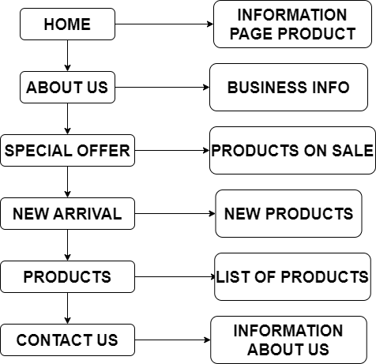



# TASK SHEET REVIEW 1

|  |  |  |  |  |  |  |  |
| --- | --- | --- | --- | --- | --- | --- | --- |
| **Project Ref. No.:**  **eP/Advertisement Portal Management**  **System/01** | | **Project Title:** | **Activity Plan Prepared By:** | **Date of Preparation of Activity Plan:** | | | |
| **Sr.**  **No.** | **Task** | **Actual**  **Start**  **Date** | **Actual Days** | **Team**  **Mate Names** | **Status** |
| 1 | Problem Statement | CRYSTAL | Vu | 19-June-23 | 1 | Vu | Completed |
| 2 | Requirements analysis | 19-June-23 | 1 | Thien | Completed |
| 3 | Partition job | 19-June-23 | 1 | Vu | Completed |
| 4 | Architecture and design of the system | 19-June-23 | 1 | Hoang | Completed |
| 5 | Diagram of the website | 19-June-23 | 1 | Thien + Hoang | Completed |

|  |  |
| --- | --- |
| **Date:19-June-2023** | |
| Signature of Instructor:  **Ms. Le Mong Thuy** | Signature of Team Leader:  **Nguyen Lam Nguyen Vu** |

# SITE MAP



# MOCK OF THE WEB SITE

1. **Homepage**

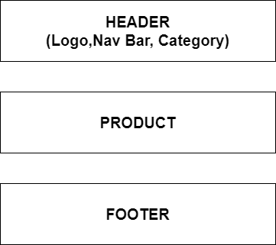

1. **About Us**

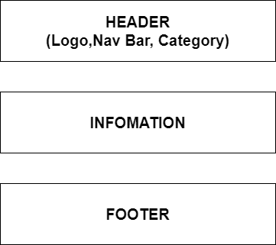

1. **Special Offer**



1. **New Arrival**



1. **Products**



1. **Contact Us**

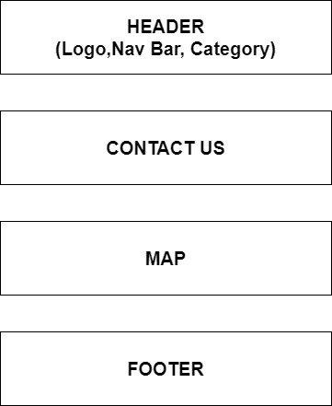

# TASK SHEET REVIEW 2

|  |  |  |  |  |  |  |  |
| --- | --- | --- | --- | --- | --- | --- | --- |
| **Project Ref. No.:**  **eP/Advertisement Portal Management**  **System/01** | | **Project Title:** | **Activity Plan Prepared By:** | **Date of Preparation of Activity Plan:** | | | |
| **Sr.**  **No.** | **Task** | **Actual**  **Start**  **Date** | **Actual Days** | **Team**  **Mate Names** | **Status** |
| 1 | Site Map | CRYSTAL | Vu | 19-June-23 | 1 | Vu | Completed |
| 2 | Mock of the website | 20-June-23 | 2 | Thien + Hoang | Completed |

|  |  |
| --- | --- |
| **Date:19-June-2023** | |
| Signature of Instructor:  **Ms. Le Mong Thuy** | Signature of Team Leader:  **Nguyen Lam Nguyen Vu** |